Electronics

Lecture 1

SEMICONDUCTOR MATERIALS:

* SEMICONDUCTOR MATERIALS: Ge, Si, AND GaAs:
* Semiconductors are a special class of elements having a conductivity between that of a good conductor and that of an insulator.
* The three semiconductors used most frequently in the construction of electronic devices are Ge, Si, and GaAs.
* The Intel ® Core TM i7 Extreme Edition Processor has 731 million transistors in a package that is only slightly larger than a 10.8 sq. centimeter.

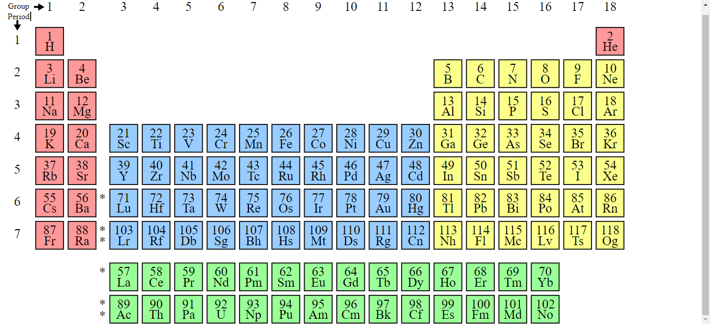

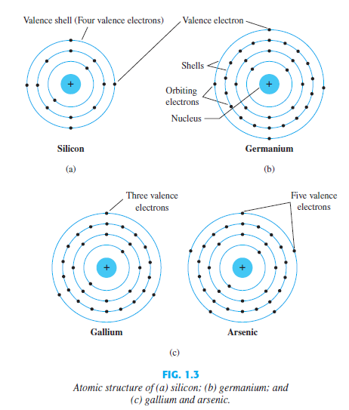

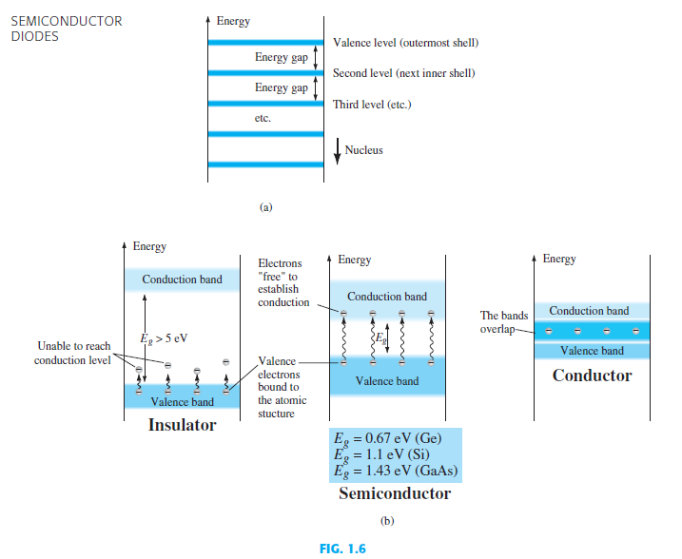

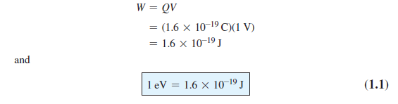

An electron in the valence band of silicon must absorb more energy than one in the valence band of germanium to become a free carrier. Similarly, an electron in the valence band of gallium arsenide must gain more energy than one in silicon or germanium to enter the conduction band.

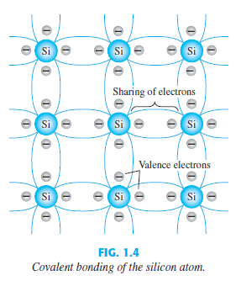

**Intrinsic:**

The term intrinsic is applied to any semiconductor material that has been carefully refined to reduce the number of impurities to a very low level—essentially as pure as can be made available through modern technology.

**Intrinsic carriers:**

Intrinsic carriers are the electrons and holes that participate in conduction. The concentration of these carriers is contingent upon the temperature and band gap of the material, thus affecting a material's conductivity.

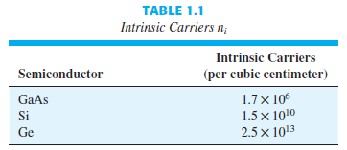

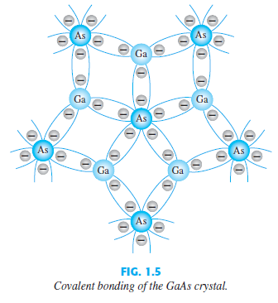

**n -TYPE AND p -TYPE MATERIALS**

A semiconductor material that has been subjected to the doping process is called an

extrinsic material.

**n -Type Material**

Both n -type and p -type materials are formed by adding a predetermined number of impurity atoms to a silicon base. An n -type material is created by introducing impurity elements that have five valence electrons (pentavalent), such as antimony, arsenic, and phosphorus. Each is a member of a subset group of elements in the Periodic Table of Elements referred to as Group V because each has five valence electrons. The effect of such impurity elements is indicated in Fig. 1.7 (using antimony as the impurity in a silicon base). Note that the four covalent bonds are still present. There is, however, an additional fifth electron due to the impurity atom, which is unassociated with any particular covalent bond. This remaining electron, loosely bound to its parent (antimony) atom, is relatively free to move within the newly formed n -type material.

Diffused impurities with five valence electrons are called donor atoms.

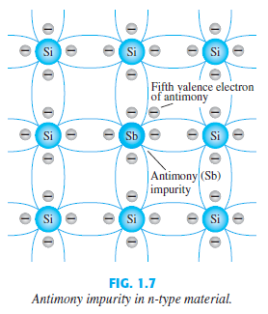

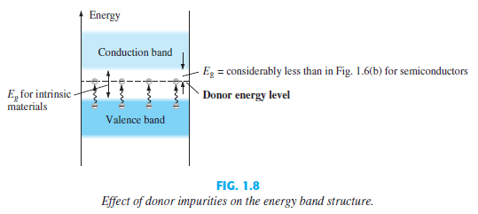

**p -Type Material**

The p -type material is formed by doping a pure germanium or silicon crystal with impurity atoms having three valence electrons. The elements most frequently used for this purpose are boron, gallium, and indium. Each is a member of a subset group of elements in the Periodic Table of Elements referred to as Group III because each has three valence electrons.

The diffused impurities with three valence electrons are called acceptor atoms.

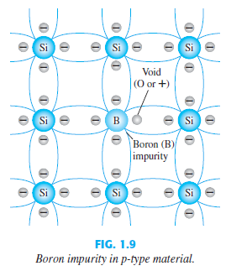

**SEMICONDUCTOR DIODE**

**No Applied Bias (V**= **0 V)**

* This region of uncovered positive and negative ions is called the depletion region due to the “depletion” of free carriers in the region.
* In the absence of an applied bias across a semiconductor diode, the net flow of charge

in one direction is zero.

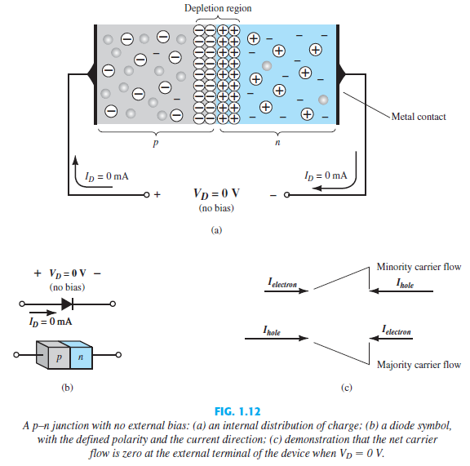

**Reverse-Bias Condition ()**

***The current that exists under reverse-bias conditions is called the reverse saturation current and is represented by .***

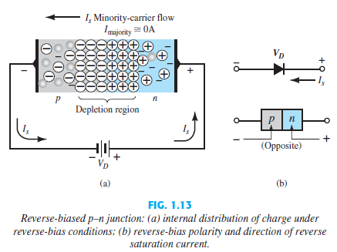

**Forward-Bias Condition**

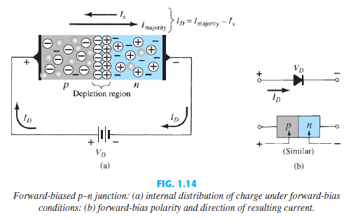

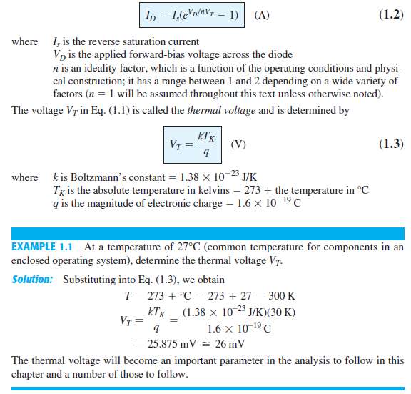

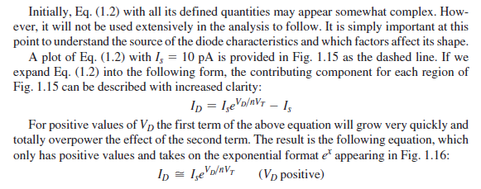

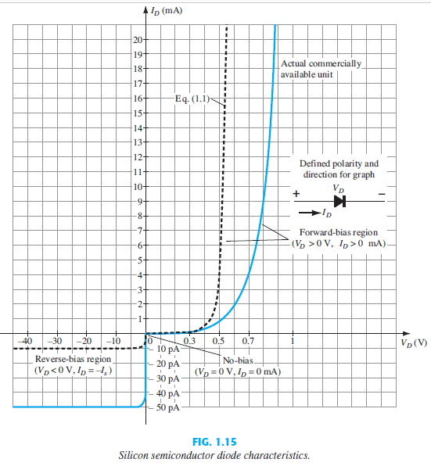

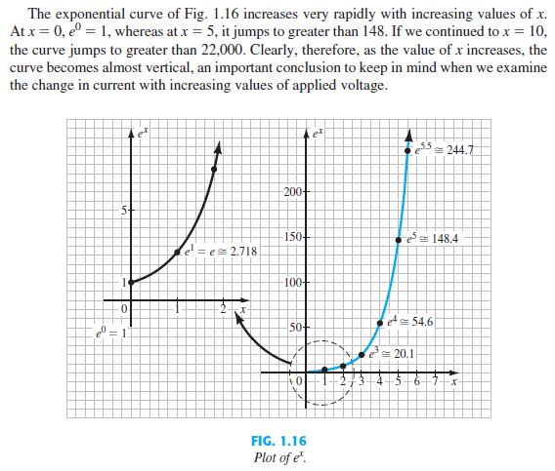

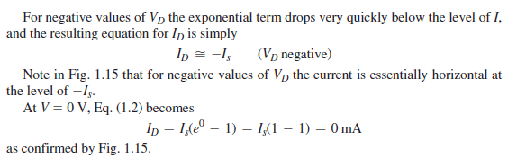

***The defined direction of conventional current for the positive voltage region matches the arrowhead in the diode symbol.***

***The actual reverse saturation current of a commercially available diode will normally be measurably larger than that appearing as the reverse saturation current in***

***Shockley’s equation.***

This increase in level is due to a wide range of factors that include

* **leakage currents**
* **generation of carriers in the depletion region**
* **higher doping levels** that result in increased levels of reverse current
* **sensitivity to the intrinsic level of carriers** in the component materials by a squared factor—double the intrinsic level, and the contribution to the reverse current could increase by a factor of four.
* **a direct relationship with the junction area**—double the area of the junction, and the contribution to the reverse current could double. High-power devices that have larger junction areas typically have much higher levels of reverse current.
* **temperature sensitivity**—for every 5°C increase in current, the level of reverse saturation current in Eq. 1.2 will double, whereas a 10°C increase in current will result in doubling of the actual reverse current of a diode.

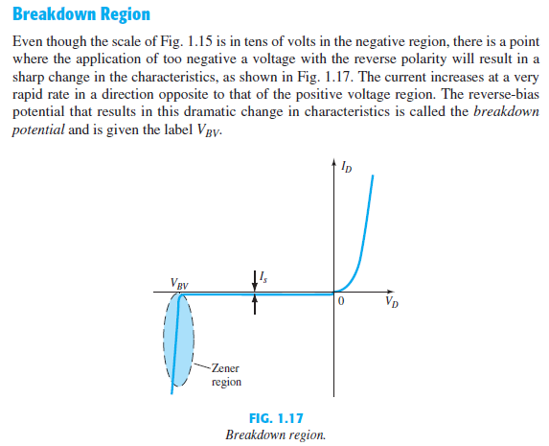

***The maximum reverse-bias potential that can be applied before entering the breakdown region is called the peak inverse voltage (referred to simply as the PIV rating) or the peak reverse voltage (denoted the PRV rating).***

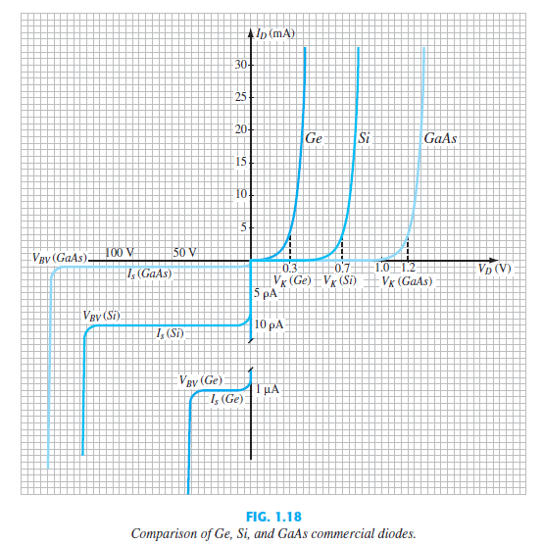

**Temperature Effects**

Temperature can have a marked effect on the characteristics of a semiconductor diode, as demonstrated by the characteristics of a silicon diode shown in Fig. 1.19:

***In the forward-bias region the characteristics of a silicon diode shift to the left at a rate***

***of 2.5 mV per centigrade degree increase in temperature.***

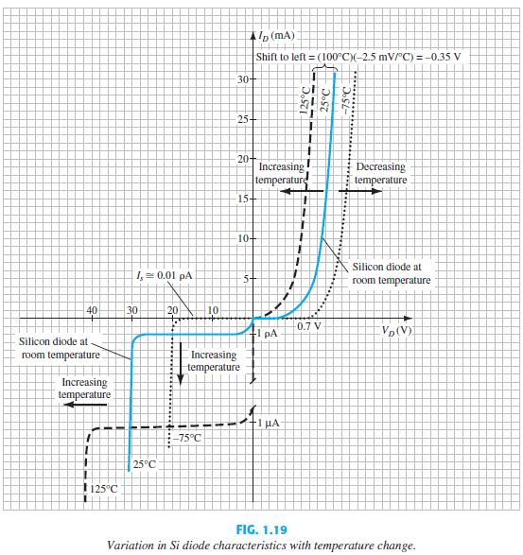

***In the reverse-bias region the reverse current of a silicon diode doubles for every 10°C rise in temperature.***

***The reverse breakdown voltage of a semiconductor diode will increase or decrease with temperature.***

**1.7 IDEAL VERSUS PRACTICAL**

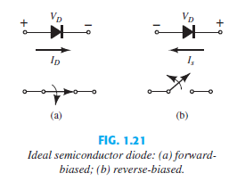

***The semiconductor diode behaves in a manner similar to a mechanical switch in that it can control whether current will flow between its two terminals.***

However, it is important to also be aware that:

***The semiconductor diode is different from a mechanical switch in the sense that when the switch is closed it will only permit current to flow in one direction.***

